PROJECT DOCUMENTATION
Salesforce
Salesforce – ServiceNow Integration for Unified Case Management
PROJECT
Automated Network Request Management

Date
Team ID
Project Name | Automated Network Request Management
Maximum Marks

1. Introduction
In organizations where customer or employee-facing cases are logged in Salesforce Service Cloud but network fulfillment happens in ServiceNow, an integration between the two platforms ensures network requests raised through Salesforce flow seamlessly into the automated ServiceNow workflow. This document describes how Salesforce integrates with the Automated Network Request Management project to provide unified case visibility across both platforms.

2. Objective
- Allow network-related cases logged in Salesforce to automatically create a corresponding request in ServiceNow.
- Keep both platforms synchronized so agents and requesters see consistent, real-time status.
- Avoid duplicate data entry between customer-facing (Salesforce) and fulfillment (ServiceNow) teams.
- Maintain a single audit trail spanning case creation through network change fulfillment.

3. Integration Architecture
A middleware/Integration Hub layer connects Salesforce Service Cloud to ServiceNow via REST APIs. When a case is logged in Salesforce and identified as a network request, the integration creates a corresponding record in the ServiceNow network request workflow and maintains bi-directional status synchronization thereafter.
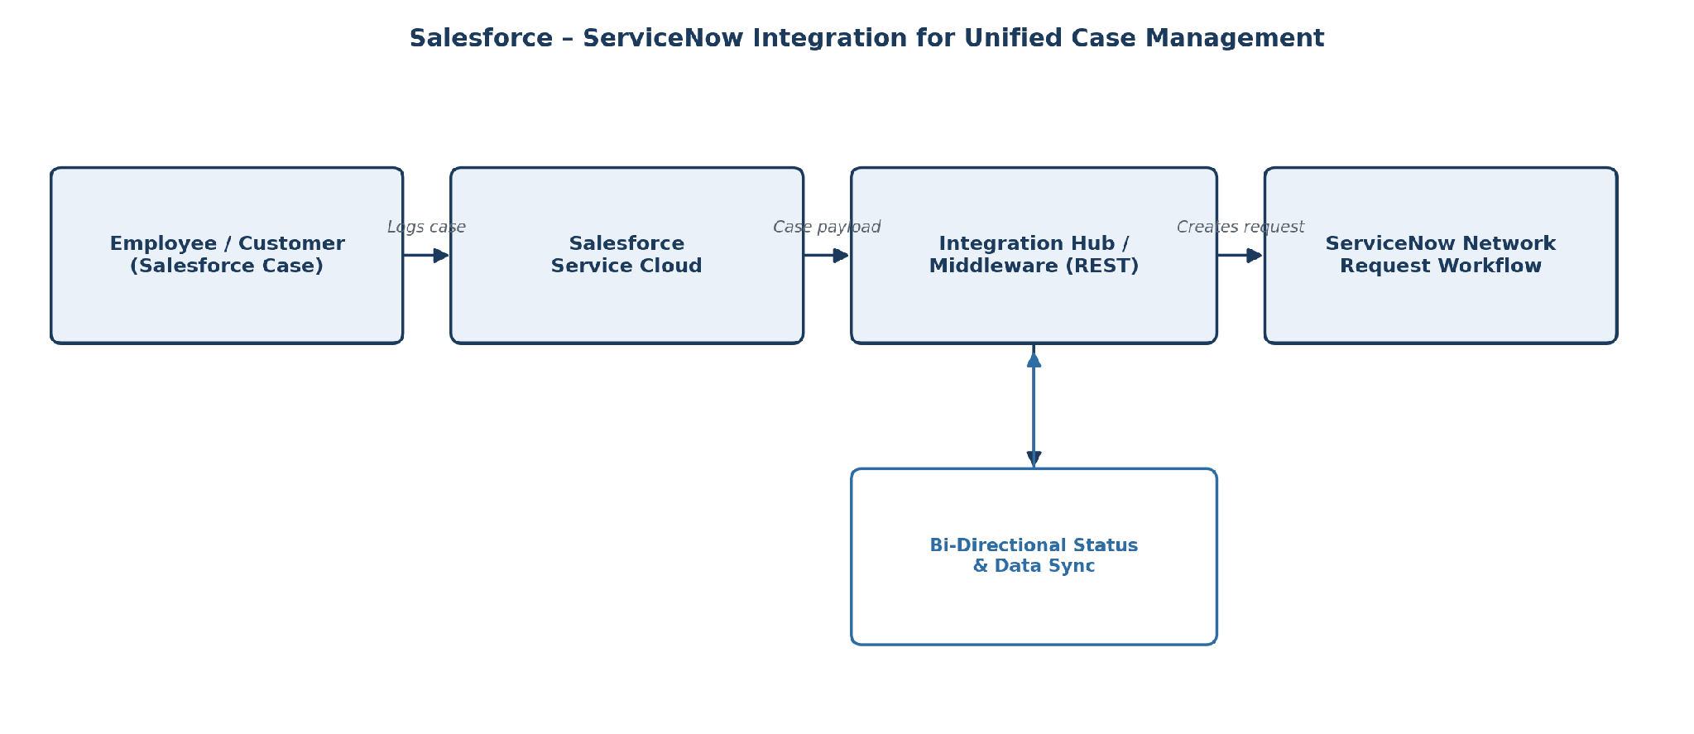
Figure 1: Salesforce–ServiceNow integration architecture for network requests

4. Integration Flow
Step | Description
1. Case creation | Employee or customer logs a network-related case in Salesforce Service Cloud
2. Case routing | Salesforce identifies the case as network-related and triggers the integration
3. Request creation | Integration Hub creates a corresponding network request in ServiceNow via REST API
4. Automated fulfillment | ServiceNow's automated workflow classifies, approves, and fulfills the request
5. Status sync | Fulfillment status updates are pushed back to the originating Salesforce case in real time
6. Case closure | Salesforce case is closed automatically once ServiceNow marks the request as fulfilled

5. Key Integration Considerations

5.1 Field Mapping
Salesforce case fields (subject, description, priority, requester details) are mapped to the corresponding ServiceNow network request fields to preserve context without manual re-entry.

5.2 Authentication & Security
The integration uses OAuth-based authentication between Salesforce and ServiceNow, ensuring only authorized case types and data are exchanged between systems.

5.3 Error Handling
Failed synchronization attempts are logged and retried, with alerts raised to the integration support team if a case cannot be created in ServiceNow, preventing silent data loss.

6. Benefits to the Project
- Extends the reach of the automated ServiceNow workflow to requests originating outside ServiceNow.
- Eliminates duplicate manual entry between customer service and network operations teams.
- Provides requesters a consistent status experience regardless of which platform they used to log the request.
- Preserves a complete, audit-ready trail from initial case to final network change record.

7. Conclusion
Integrating Salesforce with the Automated Network Request Management workflow ensures that network requests raised through customer or employee-facing channels benefit from the same rapid, automated fulfillment and audit-ready tracking as requests raised directly in ServiceNow, creating a truly unified case management experience.

